Wuzhong Zhu

Abstract

Follow this guide to prepare, install and configure your own Telegram Bot. This Bot will connect from Telegram to your Qlik Sense applications giving the users a new experience using analytics in a conversational interface.

Telegram Bot for Qlik Sense  
Version 2.1

Installation Guide



Contents

Preparation 3

Qlik Sense Server 3

Demo Kit 3

Troubleshooting 3

Installation 4

Natural Language Processing 4

Microsoft LUIS 4

Preparation 4

Spell Check 5

LUIS Application 5

Google Api.Ai 7

Natural Language Generation 7

Yseop Savvy 7

Narrative Science 8

News Search 8

Telegram Bot creation 8

Qlik Sense server 9

What you will need 9

Qlik Sense customization for Bots 9

Assumptions 10

Create a tag to identify all the modifications 10

Create Virtual Proxies 10

Streams 11

Apps 12

Bot User 12

Data Connection 12

Security Rules 13

Capture HTML 16

Telegram Bot Software installation 17

Inline mode images 17

Context and Authorization 17

Reports 18

Telegram Bot Software 18

Appendix – Troubleshooting 22

No connection could be made because the target machine actively refused it 22

SDK target system version mismatch. SDK target system version (v10.0.3) should match server version(v3.2.0) 22

Error opening the Qlik Sense app 22

Error in QSUsers with file "...": System.IO.FileNotFoundException: Could not find file '...' 22

System.Xml.XmlException 23

Chart link does not appear as a link, just as plain text 23

Chart link appear empty or like “-----“ 23

Error about licensing 23

Error “Version string portion was too short or too long” 23

The chart snapshots appear empty or a white square 23

Appendix – How to create a new Natural Language model in other language for Google Api.Ai 24

# Preparation

## Qlik Sense Server

This software will be installed in a Qlik Sense server. Because the Bot will send single object links to users to explore the Qlik Sense charts, it is recommended to use a server accessible from the internet (public IP or DNS) to allow other users to access this charts.

## Demo Kit

Unzip all the folders and files in the Telegram Bot Demo Kit.zip file to a folder in the Windows server where Qlik Sense is running:

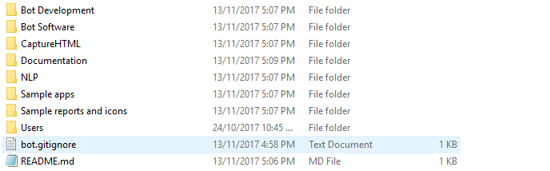

## Troubleshooting

There is a section for solving the most common problems here: Appendix – Troubleshooting. Please refer to this section in case of errors.

# Installation

Download the Telegram Bot Demo Kit, and unzip the files to your server hard disk. This will be the same server where Qlik Sense Enterprise is installed.

## Natural Language Processing

First we must create a NLP model to be used by the bot to understand what the users say in their own words.

At this moment, there are two NLP engines supported, but only one is needed. Depending on your preferences (usually based on the language you want to use for the bot), you will choose between two options for the Natural Language Processing engine to use.

As Microsoft model has some limits in the free Azure account, I prefer to use the Google engine, and this NLP model is more mature and is best trained because I have used it more. If both engines are configured, only the Google model will be used.

* **Microsoft LUIS**:

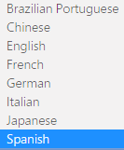

* **Google Api.Ai**:

|  |  |
| --- | --- |
| Language | Language Tag |
| Brazilian Portuguese | pt-BR |
| Chinese (Cantonese) | zh-HK |
| Chinese (Simplified) | zh-CN |
| Chinese (Traditional) | zh-TW |
| English | en |
| Dutch | nl |
| French | fr |
| German | de |
| Italian | it |
| Japanese | ja |
| Korean | ko |
| Portuguese | pt |
| Russian | ru |
| Spanish | es |
| Ukrainian | uk |

Depending on your selection, follow the corresponding section of the next ones.

### Microsoft LUIS

#### Preparation

* You need a Microsoft account (Hotmail or Outlook.com, for example)
* Go to <https://www.microsoft.com/cognitive-services/en-us/language-understanding-intelligent-service-luis>
* Optionally, you can get a Bing Spell Check key from here (<https://www.microsoft.com/cognitive-services/en-us/bing-spell-check-api>) to be used when creating your LUIS model, to spell check the sentences before trying to understand them. This could help fixing typos and mistakes in voice recognition.

#### Spell Check

This is an optional step you could follow if you want to help the Natural Language engine to spell check the sentences before trying to understand them. This could help fixing typos and mistakes in voice recognition.

1. Go to <https://www.microsoft.com/cognitive-services/en-us/bing-spell-check-api>
2. Select “Get started for free”
3. Subscribe to the Bing Spell Check. At this moment, there is a free option for 5,000 transactions per month, 7 per minute. It should be enough for demo purposes.
4. Save the Key 1 for later (it could be used in the LUIS Application configuration).

#### LUIS Application

1. Go to <https://www.microsoft.com/cognitive-services/en-us/language-understanding-intelligent-service-luis>
2. Login to LUIS, and go to My Applications.
3. Go to New App, and use the import option:

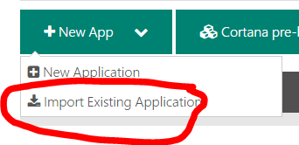

1. In case you want to use the Bing Spell Check, here is where you can enter that key (Key 1):

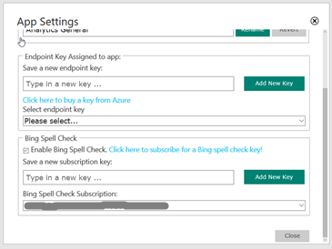

1. Use the “Analytics General.json” file you can find in the NLP folder, and give the application the name you like, in my case “Analytics General”:

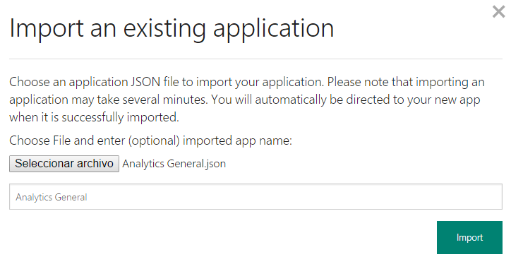

1. Train the model. You will see this option on the bottom left corner ().
2. When the train is finished, publish the application () to be able to call it from the LUIS API:

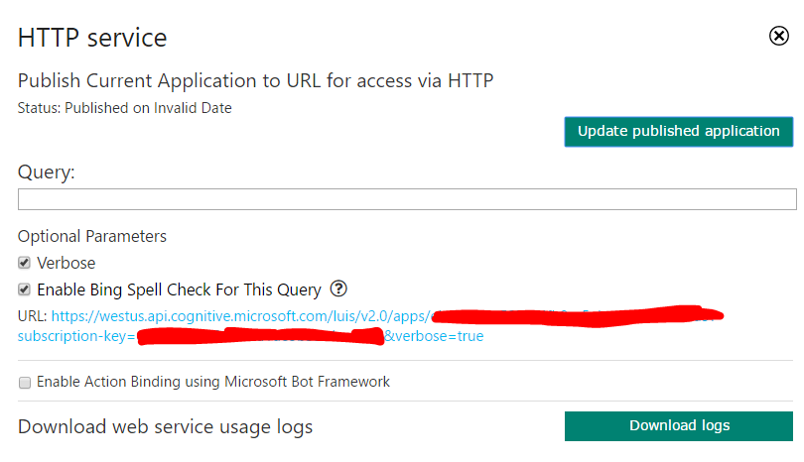

1. Here, in the URL link you can obtain the LUIS App ID and the LUIS Key, that you must save for later:

https://westus.api.cognitive.microsoft.com/luis/v2.0/apps*/<here comes the app id>*?subscription-key=*<here comes the key>*&verbose=true

1. Select Update published application

### Google dialogflow

You will need an account to login (Gmail, Facebook, Slack or Github).

1. Go to https://dialogflow.com/
2. Create an account, there is a “Sign up for Free” option, enough for demo purposes.
3. Go to the console (https://console.dialogflow.com) and create a new Agent. An agent is a NL model.
4. Choose Private if you want to keep it for yourself, or Public to be available to other people.
5. Choose English for language. If you want to create a new model for another language, check if this already available. If not, go to Appendix – How to create a new Natural Language model in other language for Google Api.Ai to create it.
6. Fill the required information (name, description, etc.) and save it:

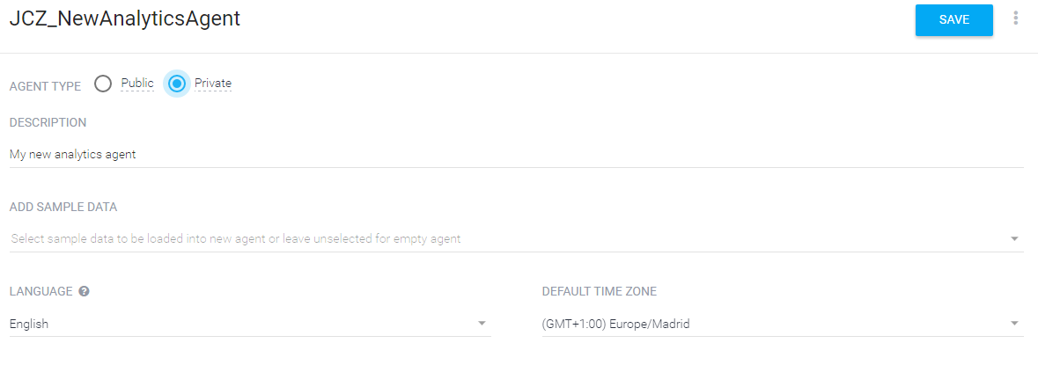

1. Go to the agent configuration , in the General tab you have both keys, Client Access Token (needed for Language Understanding, the one we need to save), and Developer Access Token (only needed if you want to make changes from the API, not needed for the bot).
2. Go to the Export and Import tab, select Import from Zip. When asked, use the file AnalyticsGeneral Google.zip included in the folder NLP Models from the Demo Kit.

## Natural Language Generation

This is also known by Narratives, and this process will interpret a set of data and generate some insights in natural language. At this moment, we are using the product Savvy (https://yseop.github.io/savvy-api/) for narratives, developed by our technology partner Yseop.

### Yseop Savvy

* Go to <https://savvy.yseop.com/download/>, and request an evaluation key (Select Api Access in the Tool section).
* Save the key for later.

### Narrative Science

* You can ask for a license key to our Technology Alliances team.
* Save the key for later.

## News Search

This service is used to show how Qlik Sense can integrate with another source of information to complement the analysis.

* Go to <https://www.microsoft.com/cognitive-services/en-us/bing-news-search-api>, and register a free account for the Bing News Search API (this account will expire in 90 days).
* Save the ID for later.

## Telegram Bot creation

Here is where you will create the Bot in Telegram and define its properties. Think first about a couple of things you will have to define during the process:

* Define the bot name and the userid. The userid could be anything, but it must end with “bot” and have no spaces. For example, Qlik Sense Bot for the name and QlikSenseBot for the userid.
* The bot profile photo, a squared photo (similar width and height), something around 250 x 250 pixel works well. Consider the copyrights for images from the internet.

You must use Telegram (from desktop, mobile and/or web), so create a Telegram account. Not needed in the Qlik Sense server, it is just to have access from some place to configure, test and demo.

To create the Telegram bot, follow the next steps:

1. Go to Telegram
2. In the contacts search box, look for BotFather. This is a bot to create bots.
3. Start a conversation with this bot.
4. Write /newbot, then you will be requested to write the name, for example Qlik Cool Bot. After this, you will be requested to write the bot userid (no spaces and ending with bot), for example QlikCoolBot.
5. If the name is not used by another bot and everything is correct, you will get a token to access the Telegram API. Save it for later, you will have to use it in Telegram Bot Software.
6. Write /setdescription, then you will have to select the bot first (with a button bellow the text), and write a description text that will appear when any user starts a conversation with the bot. For example, “*This bot connects to Qlik Sense and allows you to have an analytical conversation based on Consumer Goods Sales information*”.
7. Write /setinline, then you will have to select the bot first and write the text that will appear when the bot is called from another chat with @. For example, “Search data”.
8. Write /setinlinegeo, then you will have to select the bot first and choose Enable. This option will allow the bot to request the user geo location from the Telegram device, and use it to filter data in a Qlik Sense application.
9. Write /setinlinefeedback, then you will have to select the bot first and choose Disable.
10. Write /setuserpic, then you will have to select the bot first and upload the bot profile photo. Using the clip icon, upload the image that will appear in the bot profile.

Now, to check the bot has been successfully created, go to Telegram and using the search box in the contacts, write the name of the bot and start a conversation with him. From now on, the bot will appear on your recent list of contacts.

## Qlik Sense server

### What you will need

1. You need to have a Qlik Sense server installed (only tested with version >= 3.1).
2. Access to internet, the Bot will call different APIs on the cloud.
3. A public IP, if the bot is going to be shared with prospects and customers, for them to be able to reach the chart links that the bot suggests to users (single object links).

An option is to use our Demo Server for these public single object links, but you should use the same app (Consumer Goods Sales, for example) in our Qlik Sense server (to have the same object IDs). My recommendation is to download the app from the demo site.

To configure this option, go to the config file and review the parameters **DemoqsSingleServer** (for example, to https://sense-demo.qlik.com/site) and **DemoqsSingleApp** (something like 372cbc85-f7…).

Attention! If the user changes the app analyzed, the Single Object links won’t be valid. And no self-service will be allowed.

1. A Stream for the apps available to the bot. It could be used Everyone or one specific like Bots, or both.
2. Some demo apps published on that stream. The apps must have Master Items for Dimensions and Measures, because the Bot will use those elements for searching what to show the users. It is recommended to have enough charts in the app (not needed to be master items) with titles, as those texts will be used for names when the link is sent to users.
3. The Windows user that will run the Bot software must have read access to this stream.
   1. I recommend to create a new Windows user for the Bot, for example TelegramBot.
   2. This user must have access to Qlik Sense, for example creating a User Directory Connection for local users (Local Network).
   3. This user must have a User Access allocated (do not use login access), as the session could be running 24h a day.

### Qlik Sense customization for Bots

In this section I will show a step by step Qlik Sense server customization to allow this server to be used by Telegram users through the Bot interface.

#### Assumptions

* A Qlik Sense server already installed and licensed.
* I will use http, but https can also be used.
* I will use an anonymous virtual proxy to allow Telegram users to access the apps objects with header authentication, as this is very easy to setup, and thus making the process simpler. This is because the primary function for this bot is demo and no production.
* Every Bot user will need a token, unless core based licensing is used.

#### Create a tag to identify all the modifications

Create a Bots tag, so you can mark every object and change with this tag to find all the modifications later if needed.

#### Create Virtual Proxies

Do not forget to add the load balancing node (Central by default) and link it, after created, with a Proxy (Central by default).

Do not forget to add the IP and DNS addresses to the white list of every virtual proxy.

##### Anonymous access

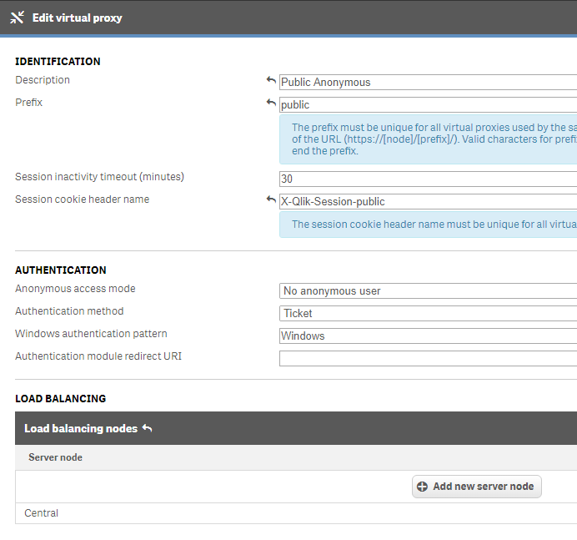

##### Telegram bot users access

Create a Virtual Proxy, for Header Authentication, with the following parameters

* Description: Telegram
* Prefix: telegram
* Timeout: 30
* Session cookie header name: X-Qlik-Session-telegram
* Anonymous access mode: No anonymous user
* Authentication method: Header authentication static user directory
* Header authentication header name: XXXXXXXXX[1]
* Header authentication static user directory: TELEGRAM

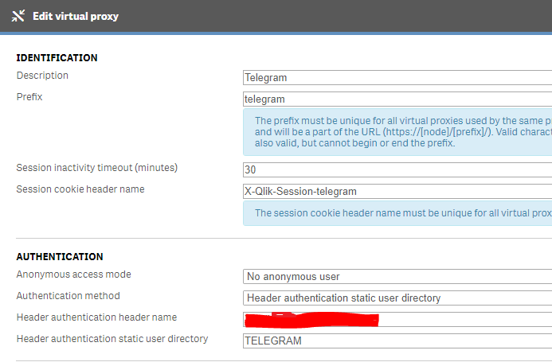

#### Streams

##### Bots

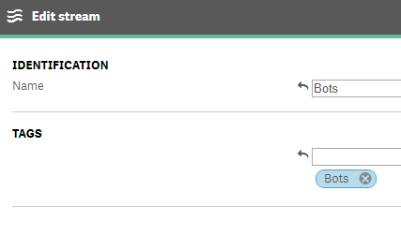 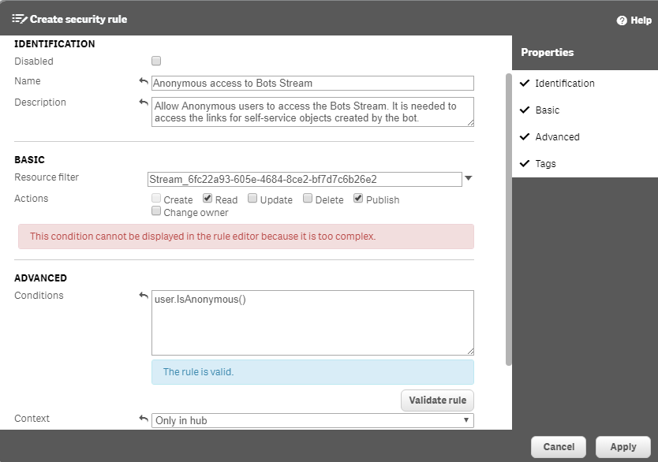

##### Bot Publications

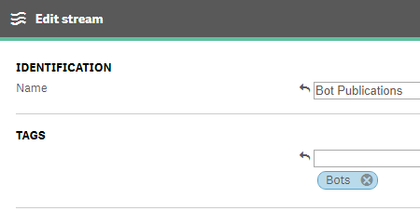 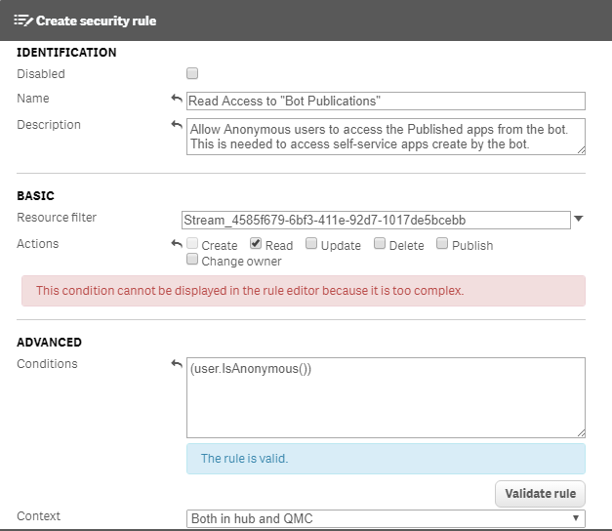

#### Apps

Now, publish all the apps that will be used in the Bot to the Bots Stream. For example, Consumer Goods Sales Bot, Retail Margin Erosion, Executive Dashboard.

There is no need to publish anything in Bot Publications. In that Stream, only the Bot will publish apps.

#### Bot User

For running the Bot software, we need to use a Windows user that will run the Bot program and connect to Qlik Sense using Windows authentication to check the API and create the Telegram Users. I recommend to create a new Windows local user, assign a token to it in Qlik Sense, and grant the Content Admin role to that user.

#### Data Connection

If we want to demonstrate full self-service from the Bot, i.e. upload a CSV file and create a new app from that data, we need to define a Folder Data Connection in Qlik Sense.

The Data Connections in Qlik Sense must be defined from the apps, so you should create a new app, then create a new Folder Connection to the folder where the Bot accesses the Reports, and then rename it from the QMC if you like (as by default the user name is added to the data connection name). Do not forget to add the Bots tag to this element in the QMC.

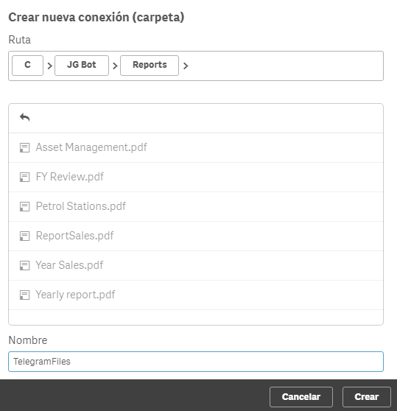

#### Security Rules

These security rules will allow all the Telegram users to access the Qlik Sense server through the Anonymous virtual proxy, but only the apps in the Bots stream (and Everyone stream, that is set by default).

##### Anonymous access to Bots Stream

Already created when the Bots Stream was created.

##### Read Access to "Bot Publications"

Already created when the “Bot Publications” Stream was created.

##### Anonymous users can access App Objects in Bots Stream

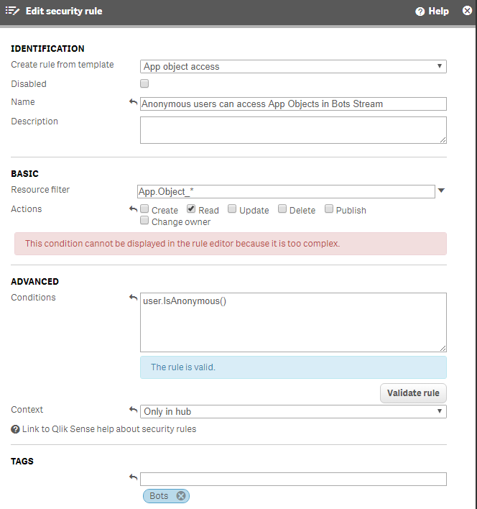

##### Anonymous users can access Apps in Bots Stream

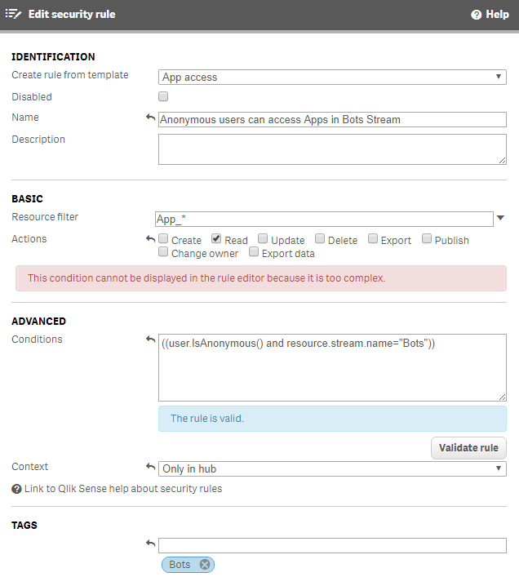

##### Modification Access to "Bot Publications"

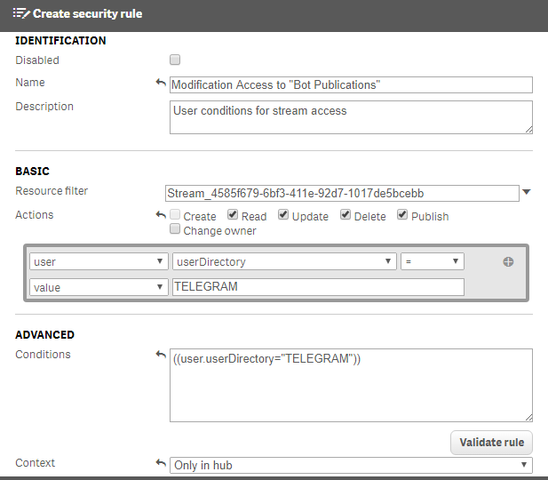

PD.- This security rule could be easier to create from the Stream menu than from the Security Rules menu.

##### Telegram users access to "Bots" Stream

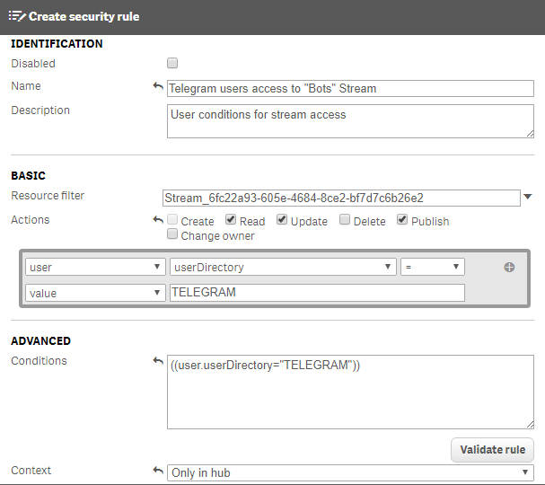

PD.- This security rule could be easier to create from the Stream menu than from the Security Rules menu. But for the Create action, you should modify the rule after creation.

##### Telegram Users can access apps in Stream Bots

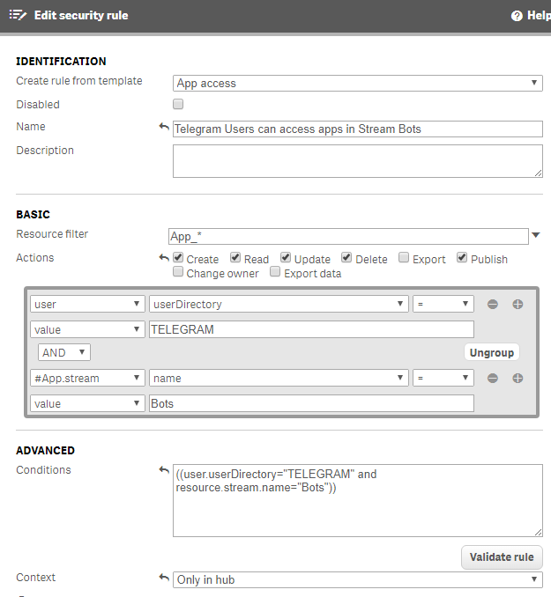

##### Telegram Users can create apps

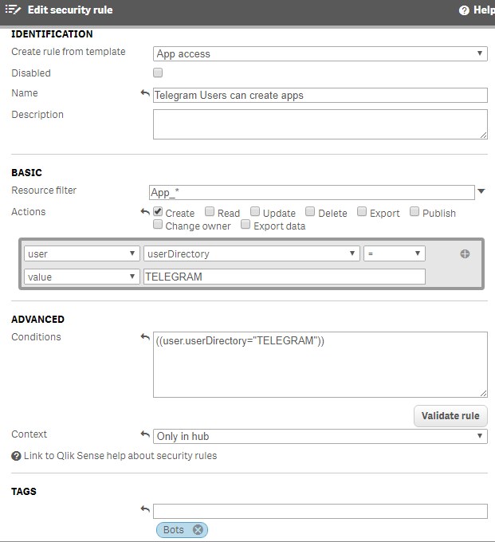

##### Telegram Users can create objects

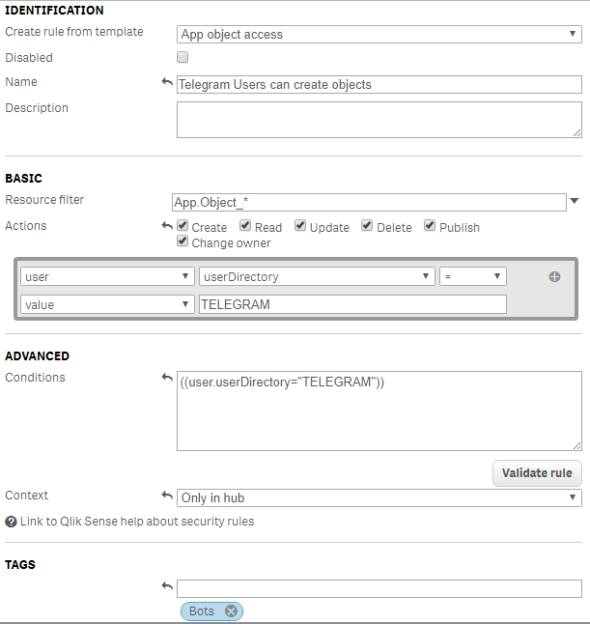

#### Capture HTML

To allow the Capture HTML app being able to connect to the Qlik Sense server to render single object images for the snapshots sent by the Bot to the users, if you use a Windows Server version you will need to add the address used by the capture app to the intranet or trusted sites in the Internet configuration. These addresses will be the ones set in the config file parameters DemoqsServer, DemoqsSingleServer and cntCaptureWeb.

## Telegram Bot Software installation

### Inline mode images

For the inline mode images that will be shown during an associative search, we will use the Qlik Sense web server to access them.

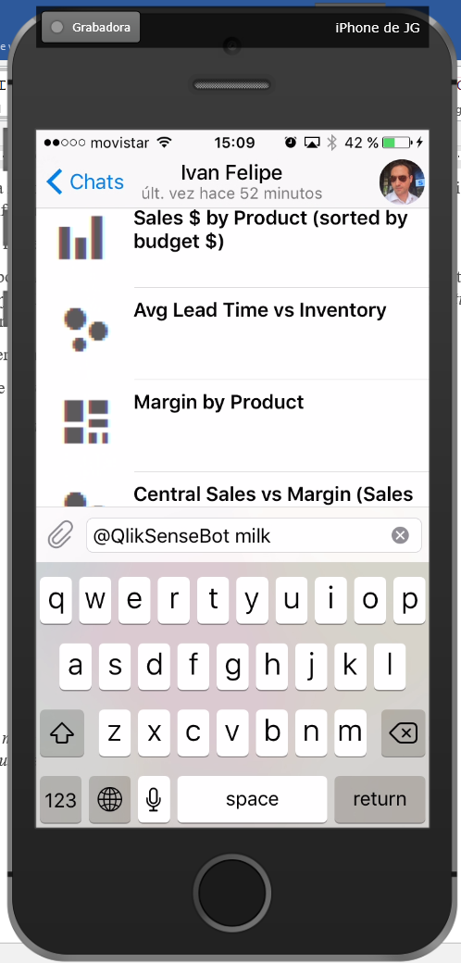

And also some chart captured images to show during the alert. They will be picked randomly from the nine available here, so you can use your own images if you like.

Copy the folder qsimg to C:\Program Files\Qlik\Sense\Client (*You will need to provide Administrator rights to write in this folder*):

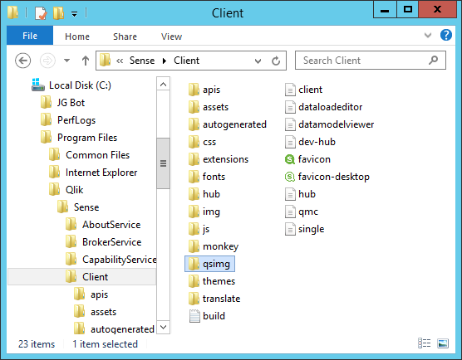

### Context and Authorization

At this moment, we track the context for every bot user by a CSV file. This file is located at C:\JG Bot\Context\QlikUsers.csv and will record every user that access the Telegram Bot, with the Telegram ID and the last time he used it.

This file has one record for every user that has accessed the bot, and has the following fields:

* UserId 🡪 Telegram User ID, this is unique for every Telegram user
* UserName 🡪 Telegram User Name
* QSUserId 🡪 Qlik Sense User ID, in case we want to map a Telegram user with an existing Qlik Sense user.
* QSUserDir 🡪 Qlik Sense User Directory, in case we want to map a Telegram user with an existing Qlik Sense user.
* QSUserName 🡪 Not used
* LastAccess 🡪 Last time the user talked to the bot
* Allowed 🡪 Y or N. If N, the bot will not answer this user, except with a message saying the user is not allowed. The default value for new users can be set in the config file.
* Language 🡪 Not used
* Email 🡪 For future use.
* AccessCode 🡪 For future use.

### Reports

In C:\JG Bot\Reports you can copy all the NPrinting reports you want to be available to the users when they ask reports to the bot. Every PDF file in this folder will be shown to the user for he to choose the one to be downloaded.

I have included some sample NPrinting reports, but you can replace or add your own reports.

The default report sent when an alert is launched can be defined in the config file.

### Telegram Bot Software

By default, on the folder C:\JG Bot\Context\Bot Software, these files form the real software program that will be running all the time, and making all the orchestration among the different APIs.

As a first step, you will have to modify the QlikSenseBot.exe.config file with all the folders in your server, and the APIs keys needed to run everything. This is a XML file, you can edit with a text editor like Notepad, for example:

Follow the instructions to change every key in this file with the correct value you have from your installation. For example, if you go to the line:

<add key = "cntBotToken" value = "Your Bot Token Here" />

You must replace the value (Your Bot Token Here) with the key value Telegram sent to your when the Bot was created (maintaining the quotation marks). The following keys must be configured in this config file before running the bot program:

| Key | Description | Example |
| --- | --- | --- |
| cntBotToken | Token in Telegram, created by the BotFather bot during the process of creating the Bot | Xxxx:d09d8a9… |
| cntBotLocalAdministrator | Telegram ID for the Bot Administrator. This contact will have access to special commands from the Bot (see the User Manual). If you do not know the ID, it can be obtained from the QlikUsers.csv file. | 12345.. |
| cntHelpInformation | Additional information that the Bot will show at the beginning of the message, when asked for **help**. | This is a cool Bot |
| cntLuisURL | The URL used for the LUIS calls, obtained when creating the model. | https://westus.api.cognitive.microsoft.com/luis/v2.0/apps/ |
| cntLuisAppID | Application ID from LUIS, obtained when creating the model.  If not used, please leave it empty, “”. | ebdb5- ebdb5… |
| cntLuisKey | Key for LUIS. It could be obtained from the URL generated when publishing a LUIS model, for example: <https://westus.api.cognitive.microsoft.com/luis/v2.0/apps/xxxxxxxxxx?subscription-key=yyyyyyy&verbose=true>, (where xxxxxxxx is the cntLuisAppID and yyyyyyy is the cntLuisKey)  If not used, please leave it empty, “”. | 64f7564f75… |
| cntApiAiKey | Key for Google Api.Ai. If this key is filled, the Google Natural Language will be used instead of the LUIS (from Microsoft).  If not used, please leave it empty, “”. | 64f7564f75… |
| cntApiAiLanguage | Language for the Google Api.Ai model. | English |
| cntSavvyKey | Key for Savvy Natural Language Generator, from Yseop. If this and next fields are empty or not included, no narratives will be generated. | ZSDcvF… |
| cntNarrativeScienceKey | Key for Narrative Science Natural Language Generator. If this and previous fields are empty or not included, no narratives will be generated. | E88bc2… |
| cntBingSearchKey | Key for Bing News Search. It is obtained when subscribing to this service. | 64f7564f75… |
| cntDefaultLanguage | Default language (from the languages implemented in the Bot software). Later, any user could change the bot language with the command language. | en-US |
| cntQlikUsersCSV | This file will contain the list of users that have connected any time to the bot. It has some other information, like the last time connected. | C:\JG Bot\Context\QlikUsers.csv |
| cntAllowNewUsers | If Y, every new user that starts a conversation with the Bot will be automatically allowed to use the bot and connect to Qlik Sense. If N, he will receive a not allowed message. | Y or N |
| cntAlternativeStreams | Semicolon separated list of Streams where the Bot will look for other Qlik Sense applications when asked by change app | Everyone;Public |
| cntStreamIdPublishNewApps | Stream ID where the new created apps (full self-service by uploading a CSV) will be published. If empty, not published. | 3b2fdf… |
| cntFolderConnection | Qlik Sense folder connection name to create new apps when uploading a CSV. This connection must point to the same folder location as the Reports (NPrintingImgsPath). Here is the connection name, not the path. | TelegramFiles |
| DemoqsServer | Qlik Sense server to connect. The user for the connection is the Windows user running the bot software. | <http://localhost> |
| DemoqsAppId | Qlik Sense application id for the application opened by default for every user | d44de225-68b… |
| DemoqsAppName | Alternative key to DemoqsAppId. It that one is empty, this one will be used to open the default app by name instead of by id. Please, notice various apps could have the same name, but the ID is always unique in every Qlik Sense server 🡪 Use DemoqsAppId. | Consumer Goods Sales |
| DemoqsServerSSL | Yes if the connection to Qlik Sense server will be done using SSL (https). No in other case. | Yes or No |
| DemoqsServerVirtualProxy | The Qlik Sense Virtual Proxy name used to access Qlik Sense from the Bot. I recommend to use other virtual proxy different to the Central, to better manage the access, the authentication, etc. | telegram |
| DemoqsServerHeaderAuth | Name of the Header authentication header name parameter, from the virtual proxy configuration. | C:\JG Bots\client.pfx |
| DemoqsSingleServer | Qlik Sense server used to build single object links. It is recommended this server is a public server (public IP), to be accessible from any other user. | https://sense-demo.qlik.com/site |
| DemoqsSingleApp | App Id for the single object link. Usually it has the same value as DemoqsAppId, and only changes if using different Qlik Sense servers for opening the app and for building the links. | 372cbc85-f7… |
| cntQSSheetForAnalysis | Sheet Id for the open app command from the Bot. When asked for kpi, the bot will show some kpis and an option to navigate to the app in the Hub, for self-service. | jDSPJ |
| NPrintingImgsPath | Folder that contains the PDF report files to be shown to the user when asking for reports. | C:\JG Bots\Reports |
| NPrintingDefaultReport | Default report file name from the above folder to be sent when an alert is launched. | ReportSales.pdf |
| AlertSeconds | Number of seconds when the alerts will be checked periodically. Consider all the alert conditions will be true when this timer run, to simulate what will happen in a real scenario. | 60 |
| LogFilePath | Log files folder, if you want them in a different folder than the application. | C:\Logs |
| cntCaptureImageApp | Capture image application path | C:\JG Bots\Bot Software\CaptureHTML\ CaptureHTML.exe |
| cntCaptureWeb | Qlik Sense single object address to navigate for a chart image. This is in case the internal server name is different from the external name. | http://myserver |
| cntCaptureTimeout | Number of seconds to wait for a chart to render and capture. | 10 |
| cntCheckSDKVersion | Option used to avoid Qlik Sense Engine for checking the SDK version used by the Bot software. I will avoid version mismatch problems. It can be N or Y. | N |

If you want to use a template for this file, here you have one based on the default settings described in this document, where you can fill the gaps (specially the Bot token and the qsserver name):



Now that everything is configured, go to the C:\JG Bot\Bot Software folder, and run the program QlikSenseBot.exe.

A Windows Console application will run, and every start step will be shown in the console window. Check there are no error messages, like in the following image:

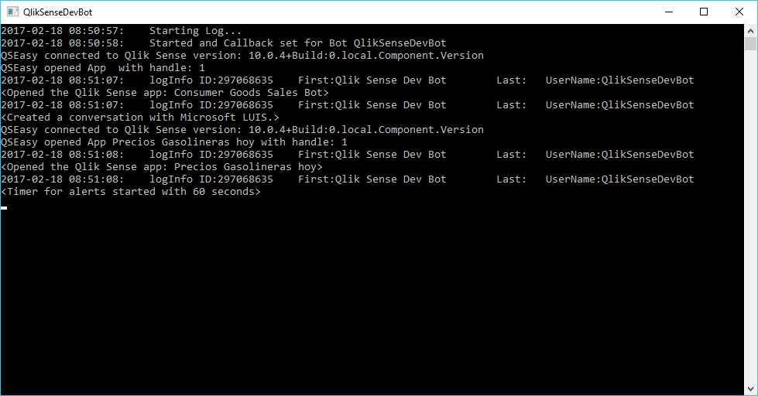

# Appendix – Troubleshooting

## No connection could be made because the target machine actively refused it

¿Have you assigned a token to the user running the bot software? ¿Does he have access to the stream and app configured for the Bot?

Try to access the hub from this user.

¿Is HTTP enabled?

## SDK target system version mismatch. SDK target system version (v10.0.3) should match server version(v3.2.0)

If you get this error, it is caused because the Qlik Sense Engine version and the .Net SDK version in the Bot software are not the same, and by default Qlik Sense gives an error.

We can tell Qlik Sense to avoid this version checking by setting the parameter cntCheckSDKVersion to N, in the config file.

## Error opening the Qlik Sense app

If you get an error like:

Error opening the Qlik Sense app : System.NullReferenceException: Object reference not set to an instance of an object. at Qlik.Engine.Session.WithApp(IAppIdentifier appIdentifier, String sessionToken) at Qlik.Engine.LocationExtensions.App(ILocation location, IAppIdentifier appIdentifier, ISession session, Nullable`1 noVersionCheck, Boolean noData)

This could be happening because the virtual proxy the Bot is connecting to the local Qlik Sense server is configured to allow Anonymous user. Change this setting to No anonymous user:

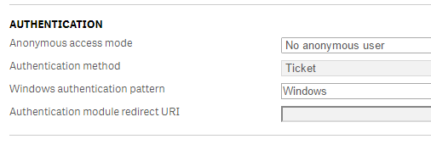

## Error in QSUsers with file "...": System.IO.FileNotFoundException: Could not find file '...'

The QlikUsers.csv file does not exist or the path in the config file is not correct.

## System.Xml.XmlException

And probably the program will stop working and Windows will propose to close it.

This could be due to format error in the config file. For example, you have changed something but have delete an end symbol “>”, or not closing a string value with quotes, check the config file has a valid XML format.

## Chart link does not appear as a link, just as plain text

If you use <http://localhost> for the Qlik Sense server for single objects, Telegram will remove the links to localhost (I think it is for security).

Use a link with a valid IP or name.

## Chart link appear empty or like “-----“

The proposed chart has no title.

The Bot uses the Chart title, thus the recommendation is to fill titles in the app charts.

## Error about licensing

Not sure yet, but it could be due to the limitation to a maximum of 5 simultaneous sessions for one user. And as the bot software is using only one user now (until authentication is solved), it could happen with high concurrency.

Try waiting for a couple of minutes and start the bot again, and review the licenses for the Bot user.

## Error “Version string portion was too short or too long”

First detected with June 2017 version, this error has the same origin as SDK target system version mismatch. SDK target system version (v10.0.3) should match server version(v3.2.0). So you should set the parameter cntCheckSDKVersion to N, in the config file.

## The chart snapshots appear empty or a white square

Add the address used by the capture app to the intranet or trusted sites in the Internet configuration. These addresses will be the ones set in the config file parameters DemoqsServer, DemoqsSingleServer and cntCaptureWeb.

Also, be sure Enable Integrated Windows Authentication is enabled in the Internet Options, so the user running the bot program will be able to access the single object link.

# Appendix – How to create a new Natural Language model in other language for Google Api.Ai

This process will create a new Natural Language model that could be configured in the bot config file to understand sentences in other languages different from English. There are some considerations when using another language:

* It is advisable to use a Qlik Sense app with the master items in this language, to avoid mixing languages in the same sentence and confusing the NL engine.
* If you also want to have the bot messages translated, contact me ([juan.cabeza@qlik.com](mailto:juan.cabeza@qlik.com)) to include a resources translation for your language in the bot software.

To create a new model with a new language, follow the instructions:

1. Create a new agent in your Google Api.Ai console (<https://console.api.ai>)
2. Create the Entities:
   1. @Dimension
   2. @Element
   3. @Measure
   4. Create the Intents, as defined in the following table. The sample sentences that are shown here are in English, but they must be introduced in the new language. The names for Intents, Actions and Parameter must be as defined in the table (not translated).

| Intent | Action | Parameters | Examples in English (use in your language) |
| --- | --- | --- | --- |
| Apologize | Apologize | None | I'm sorry  forgive me |
| BadWords | BadWords | None | You are stupid  i hate you |
| ChangeLanguage | ChangeLanguage | None | Speak in English  talk in french |
| ContactQlik | ContactQlik | None | how to contact with Qlik?  What is Qliksense? |
| CreateCollaborationGroup | CreateCollaborationGroup | None | I want to share this  share this information |
| GoodAnswer | GoodAnswer | None | Cool!  Great! |
| Help | Help | None | Help  Demo  How can you help me? |
| qs-Alert | Alert | |  |  |  |  | | --- | --- | --- | --- | | R | Param | Entity | Value | | Yes | Measure | @Measure | $Measure | | Yes | Percentage | @sys.percentage | $Percentage | | alert me if sales go down by 6%  warn me if sales increase 5%  give me a shout if sales change by 5% |
| qs-ClearAllFilters | ClearAllFilters | None | Clear all filters  Remove all filters  Clear all |
| qs-ClearDimensionFilter | ClearDimensionFilter | |  |  |  |  | | --- | --- | --- | --- | | R | Param | Entity | Value | | Yes | Dimension | @Dimension | $Dimension | | Clear the filter of product  Remove category  Clear family |
| qs-CreateChart | CreateChart | |  |  |  |  | | --- | --- | --- | --- | | R | Param | Entity | Value | | Yes | Measure | @Measure | $Measure | | Yes | Dimension | @Dimension | $Dimension | | No | Element | @Element | $Elemet | | No | ChartType | @ChartType | $ChartType | | No | Dimension | @Dimension | $Dimension1 | | create a barchart with sales by customer for milk  I want a linechart for cost by state in florida |
| qs-CurrentSelections | CurrentSelections | None | What are the current selections  what is selected now?  What are my selections? |
| qs-Filter | Filter | |  |  |  |  | | --- | --- | --- | --- | | R | Param | Entity | Value | | Yes | Element | @Element | $Element | | No | Dimension | @Dimension | $Dimension | | No | Measure | @Measure | $Measure | | No | Value | @sys.number | $Value | | No | Percentage | @sys.percentage | $Percentage | | Filter by Florida  filter state equal Alabama  what about Florida? |
| qs-GeoFilter | GeoFilter | |  |  |  |  | | --- | --- | --- | --- | | R | Param | Entity | Value | | No | Dimension | @Dimension | $Dimension | | No | Distance | @sys.number | $Distance | | No | DistanceUnit | @sys.unit-length-name | $DistanceUnit | | Show me the customers within 100 kilometers  Show me the customers close to me |
| qs-RankingBottom | RankingBottom | |  |  |  |  | | --- | --- | --- | --- | | R | Param | Entity | Value | | No | Dimension | @Dimension | $Dimension | | No | BottomNumber | @sys.number | $BottomNumber | | loss making customers  show me the worst customers  bottom 4 customers |
| qs-RankingTop | RankingTop | |  |  |  |  | | --- | --- | --- | --- | | R | Param | Entity | Value | | No | Dimension | @Dimension | $Dimension | | No | TopNumber | @sys.number | $TopNumber | | top 5 customers  show me the best customers |
| qs-Reports | Reports | None | What are the available reports  show me a report  What reports do you have |
| qs-ShowAllApps | ShowAllApps | None | change the app  show me the apps  what are the applications? |
| qs-ShowAllDimensions | ShowAllDimensions | None | show me the available dimensions  dimensions  Can I select a dimension? |
| qs-ShowAllMeasures | ShowAllMeasures | None | Choose a measure  what are the measures?  Can I select a measure? |
| qs-ShowAllSheets | ShowAllSheets | None | show me the sheets  Can I select a sheet? |
| qs-ShowAllStories | ShowAllStories | None | show me the stories  Can I select a story? |
| qs-ShowAnalysis | ShowAnalysis | |  |  |  |  | | --- | --- | --- | --- | | R | Param | Entity | Value | | No | Dimension | @Dimension | $Dimension | | No | Measure | @Measure | $Measure | | Show me analytics  give me some analysis |
| qs-ShowChart | ShowChart | |  |  |  |  | | --- | --- | --- | --- | | R | Param | Entity | Value | | Yes | Dimension | @Dimension | $Dimension | | Yes | Measure | @Measure | $Measure | | show me the revenue by city  show me the sales by country  sales by región |
| qs-ShowElementsAboveValue | ShowElementsAboveValue | |  |  |  |  | | --- | --- | --- | --- | | R | Param | Entity | Value | | No | Dimension | @Dimension | $Dimension | | No | Measure | @Measure | $Measure | | No | Percentage | @sys.percentage | $Percentage | | No | Number | @sys.number | $Number | | how many customers with sales above 3000?  Which products have margin above 15% |
| qs-ShowElementsBelowValue | ShowElementsBelowValue | |  |  |  |  | | --- | --- | --- | --- | | R | Param | Entity | Value | | No | Dimension | @Dimension | $Dimension | | No | Measure | @Measure | $Measure | | No | Percentage | @sys.percentage | $Percentage | | No | Number | @sys.number | $Number | | show me the customers with sales bellow 5%  Tell me which deals have margins less than 20% |
| qs-ShowKPIs | ShowKPIs | None | Show me KPI  what are my kpis? |
| qs-ShowListOfElements | ShowListOfElements | |  |  |  |  | | --- | --- | --- | --- | | R | Param | Entity | Value | | No | Dimension | @Dimension | $Dimension | | No | Element | @Element | $Element | | list all state names  Show me the list of customers with milk |
| qs-ShowMeasure | ShowMeasure | |  |  |  |  | | --- | --- | --- | --- | | R | Param | Entity | Value | | Yes | Measure | @Measure | $Measure | | may I know the sales?  show me the expenses  let me know the margin |
| qs-ShowMeasureByMeasure | ShowMeasureByMeasure | |  |  |  |  | | --- | --- | --- | --- | | R | Param | Entity | Value | | Yes | Measure | @Measure | $Measure | | Yes | Measure2 | @Measure | $Measure2 | | Yes | Dimension | @Dimension | $Dimension | | i want sales vs margin across state  What's the performance vs budget |
| qs-ShowMeasureForElement | ShowMeasureForElement | |  |  |  |  | | --- | --- | --- | --- | | R | Param | Entity | Value | | Yes | Measure | @Measure | $Measure | | Yes | Element | @Element | $Element | | show me the sales for cookie  give me the inventory for wine  show me the sales for tandy |
| qs-Hello | Hello |  | How do you do?  Hello  Hi |
| qs-Bye | Bye |  | Bye  Goodbye  See you |

1. To train the Natural Language model (or agent), it is recommended to use quite sentences in every intent, and review and correct the parameters identification. Try with some sentences in the new language.
2. In the Training section, there are more possibilities to train the model. Mainly, reviewing the history of requested sentences, and uploading a set of sentences to review and train the model. Do this periodically, especially at the beginning.

1. Save the "Header authentication header name" for later, as this parameter has to be used in the bot program config file (DemoqsServerHeaderAuth). I have put it in red, but you can use whatever name you want, for example X-Qlik-TelHeadAuth.